Obico for Klipper Remote control printer
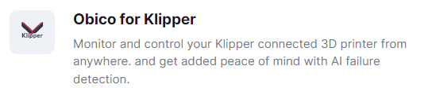
- During the installation process, it is necessary to be within the same local area network. Firstly, connect to the printer's back end through the SSH protocol on the computer terminal.(Username is "ideaformer", and for the IP address, please refer to the one displayed on your screen. The password is 1234.)
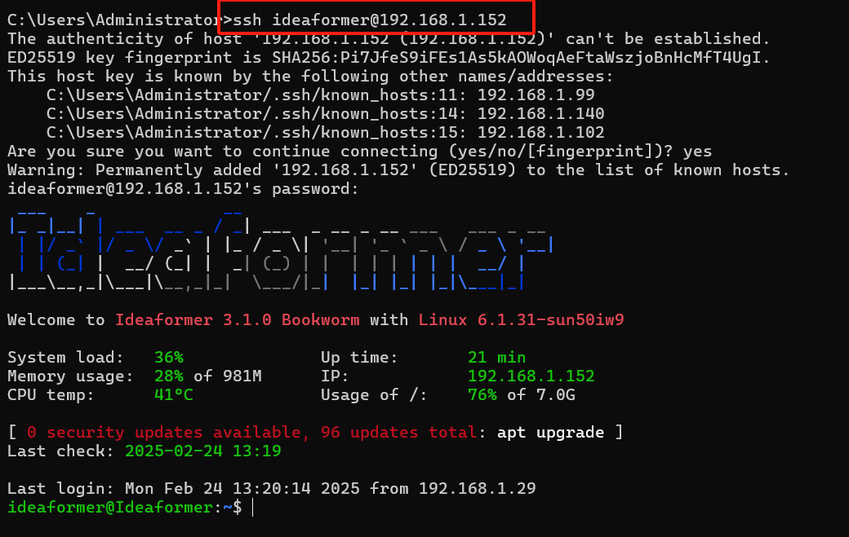

- Download and pull moonraker-obcio：
git clone https://github.com/TheSpaghettiDetective/moonraker-obico.git
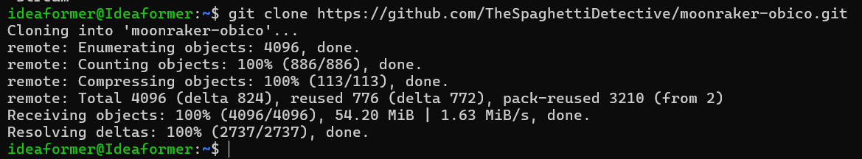

- Enter the moonraker-obcio directory and run the installation program.
./install.sh
- Open the browser on your mobile phone.
Open the obico website: https://www.obico.io/ . (Your mobile phone doesn't have to be within the same local area network.)
Register or log in to your account (You can log in via Facebook.)
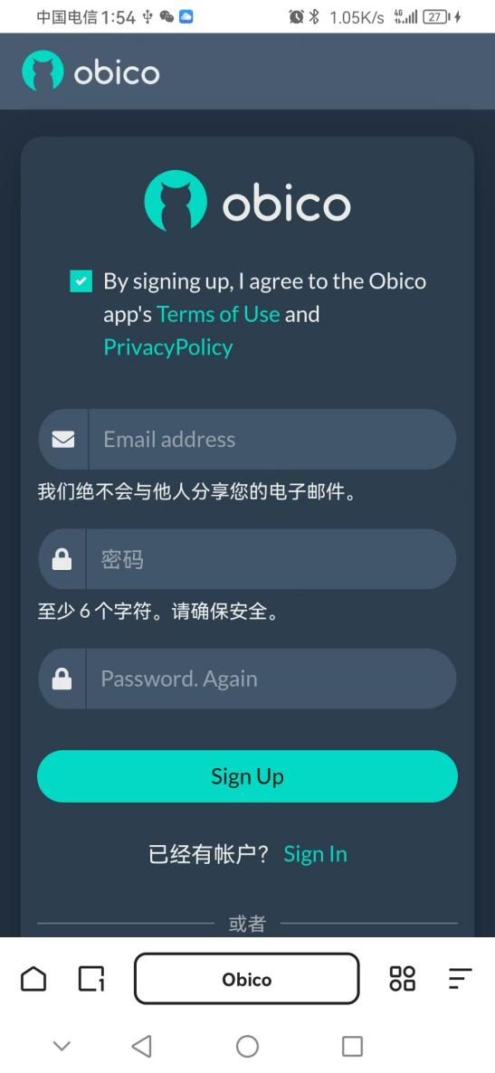

- Add your printer.
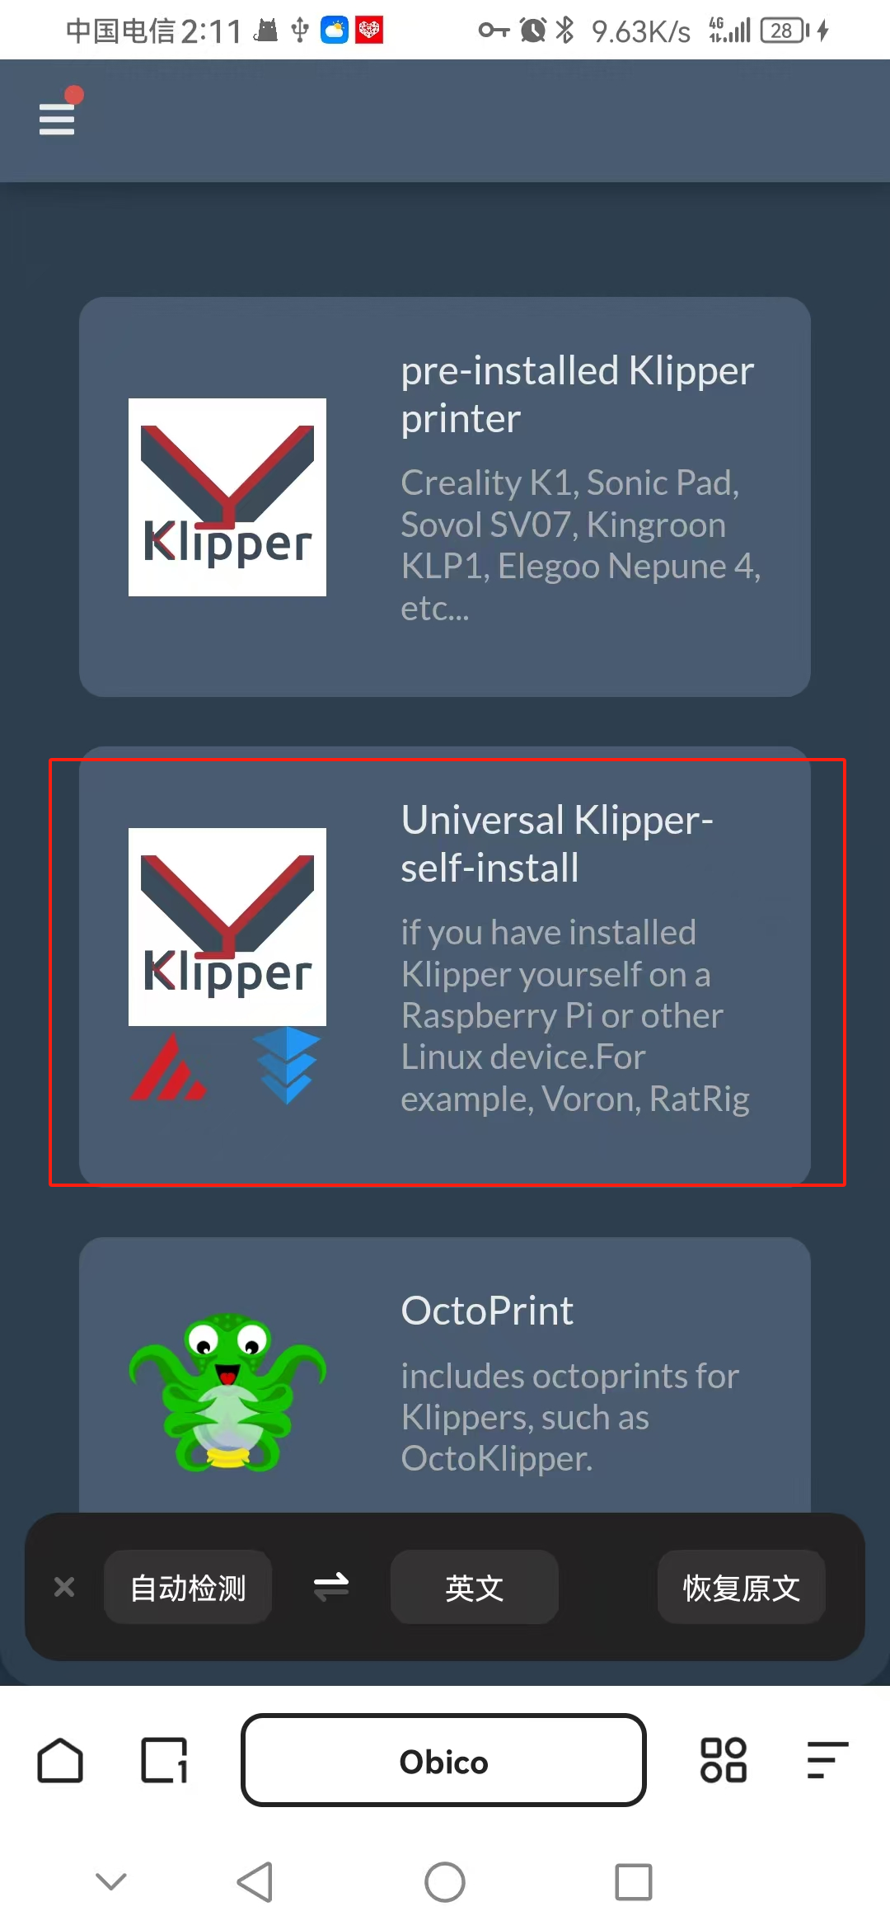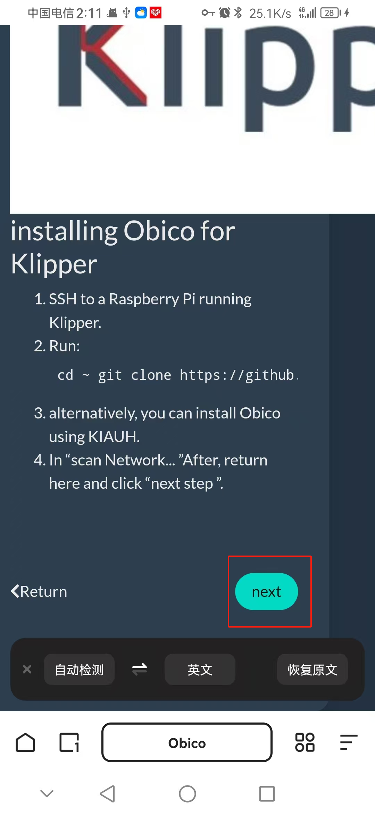
- Select Switch to manual link.
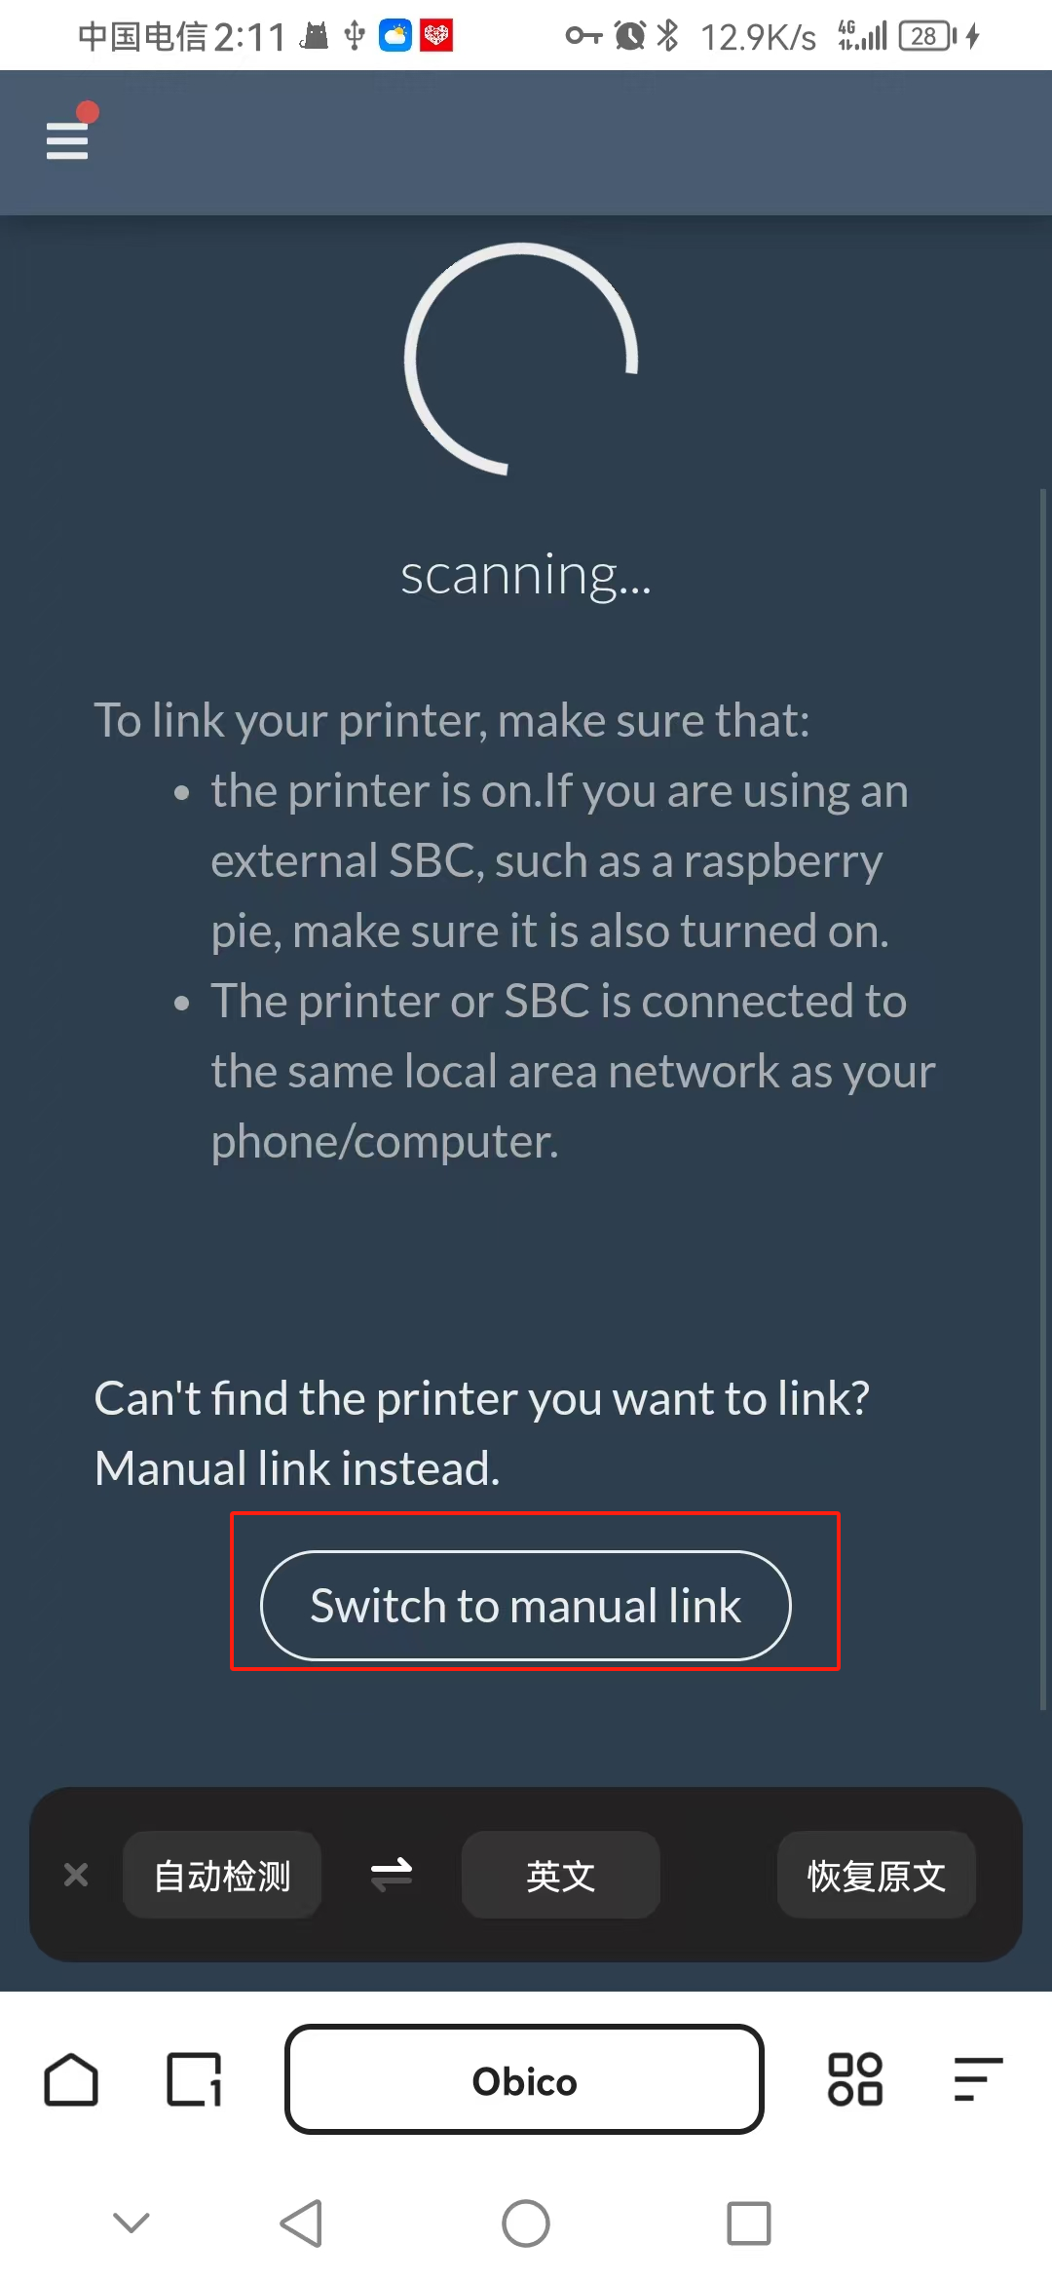

- Input the verification code displayed on the terminal into the mobile phone.
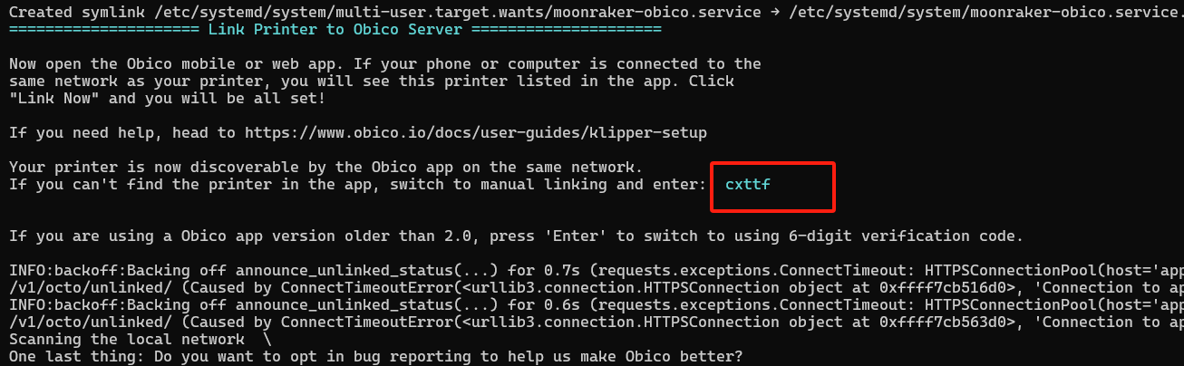
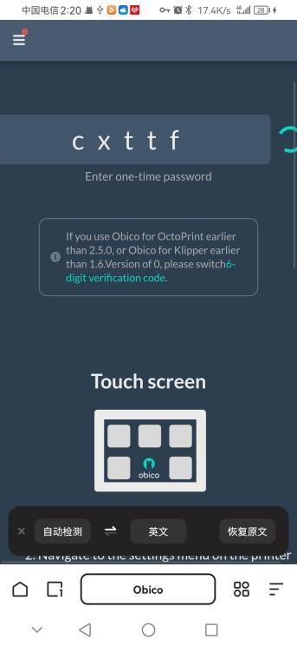
Now you have successfully connected to your printer source.

